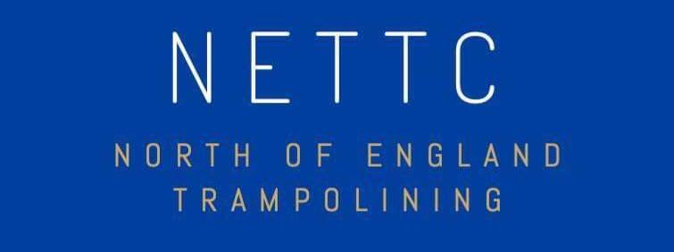
North of England Trampoline Squad Selection Policy 2023

Section 1. Eligibility for Selection
Any gymnast wishing to be considered for selection must be a full member of British Gymnastics. In addition, upon selection they must abide by the rules and regulations of the North of England Squads.
Section 2. Selection Panel
The selection panel will consist of, the TRA squad director, NETTC Chairperson, and the squad coaches. The key responsibilities of the panel will be to select and inform the gymnasts who has been selected.
Section 3. Selection process
The timescale for the squad will vary each year depending on the regional semi-finals and inter-regional challenge cup final. Competitors who qualify to represent the North of England, and enter the inter-regional challenge cup final, will automatically become part of the regional squad that year. If a gymnast is unable to attend the Inter regional challenge up final they will not be eligible to join the squad.
FIG level gymnasts whose clubs have submitted an expression of interest, may be invited for assessment at the first squad training session. There they will be assessed on their skills (matrix skill box section 5). Following assessment, letters will be emailed to invite successful competitors into the North of England squad. Clubs wishing for their FIG Level gymnasts to be assessed should email squad@nettc.org.uk by Sunday 25th June. Only gymnasts who are attending the national age group 2023 can apply. Those gymnasts who are already on a national/home nation’s squad cannot apply to be a part of the North of England squad.
Each gymnast will receive a letter of the training dates, venue, and kit order form.
Section 4. General Information
In the event of a squad member’s circumstances changing such that they are unable to compete at the inter-regional challenge cup final (for example injury or removal from the squad by the squad director) they will relinquish their space in regional squad. The place may then be offered to another eligible competitor.
Section 5. FIG Assessment Day
Following the FIG assessment day, the maximum of 15 female and 15 males from each age group (age groups 10 -14 & 15-21) will be considered for inclusion on to the North of England squad and will be notified via email to their clubs. The maximum number of FIG places offered will be determined by the squad director each year and will be the maximum number without having an adverse effect on the squad members how are preparing for the inter-regional challenge cup final.
Below is the matrix the FIG gymnasts will be assessed on
 | Drill | Execution | HD | TOF
1 | BSS (T), Barani (T) x 5 | Yes | Yes | Yes
2 | BSS (P), Barani (P) x 5 | Yes | Yes | Yes
3 | BSS (S), Barani (S) x 5 | Yes | Yes | Yes
4 | ¾ FSS, barani ball out | Yes | Yes | Yes
5 | ¾ BSS, Cody | Yes | Yes | Yes
6 | 1 ¾ (T) | Yes | Yes | Yes
7 | ½ twist into ¾ FSS | Yes | Yes | Yes
8 | WAG | Yes | Yes | Yes
9 | Vol | Yes | Yes | Yes
10 | 10 foot bounce from standing | Yes | Yes | Yes

Dates of 2023 Regional Squads:
SUNDAY 30TH JULY & SUNDAY 3RD SEPTEMBER
Both Squads will be running at Velocity Trampoline Gymnastics Club, Billingham, TS23 3HB.

If you have any queries relating to the above, please contact the squad director via email: squad@nettc.org.uk

